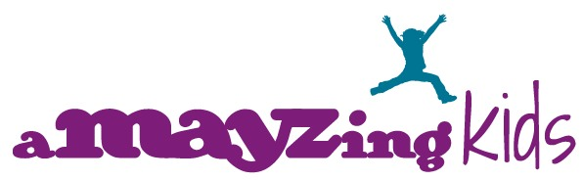

Occupational Therapy FEEDING Pre-Exam Questionnaire
In order to evaluate your child’s condition fully, please be as accurate as possible. Thank you.

Child’s Name _____________________________ Date of birth____________ Age:__________________________

Child’s Current Weight _______________________ Growth Chart Percentile_______________________________
Was/is your child breast fed? Yes No
Was/is your child bottle fed? Yes No
Drinks from: bottle breast sippie cup straw open cup
Utensils used: fork spoon finger fed caregiver assist
Special Diet: Yes No
Shows signs of hunger: Yes No
Food texture preferences - crunchy, smooth, warm, cold
Feeding environment High Chair___ Table___ Walks Around____ Other____________
How long does your child sit for a meal?
 | Yes | No
Over-stuffing mouth with food
Gags/vomits during feedings
Frequently drools
Messy eater
Strong food preferences
Picky eater
Avoids face washing
Avoids tooth brushing
Not chewing food
Spillage of food/drinks from their mouth
Avoids being messy
Pocketing
Grazes
Throws food
Difficulties using cup and/or straw
Mouths objects/fingers
History of or concerns with:
 | Yes | No
Reflux
Vomiting
Constipation
Diarrhea
Slow Gastric Emptying
Failure to Thrive
Food likes (please list)

Food dislikes (please list)

Childs feeding schedule:

- What are your primary concerns and the primary problems? Are you concerned about your child’s safety while eating? Please describe:

- 7. On the scale below circle your level of concern for your child:

Mild Moderate Severe
0 . . . 1 . . . 2 . . . 3 . . . 4 . . . 5 . . . 6 . . . 7 . . . 8 . . . 9 . . . 10

- How often do you experience these problems with your child? Constantly Daily Weekly

- Are any of your family’s everyday activities affected? Yes No
  - If yes, describe how.

- What do you think has caused this problem?

- Approximately when did it start?___________ Is it getting worse, better, or staying the same?

- Has your child had these problems before? Yes No

