PATIENT COMPLETES THIS SECTION
Child Name____________________________________ Age______ Parent Name(s)__________________________________
Regular Activities: _________________________________________________
- Where and what is your area of Concern? (Indicate on the diagram below) and briefly describe: _____________________________________________________________________________________________________________________________________________________________________
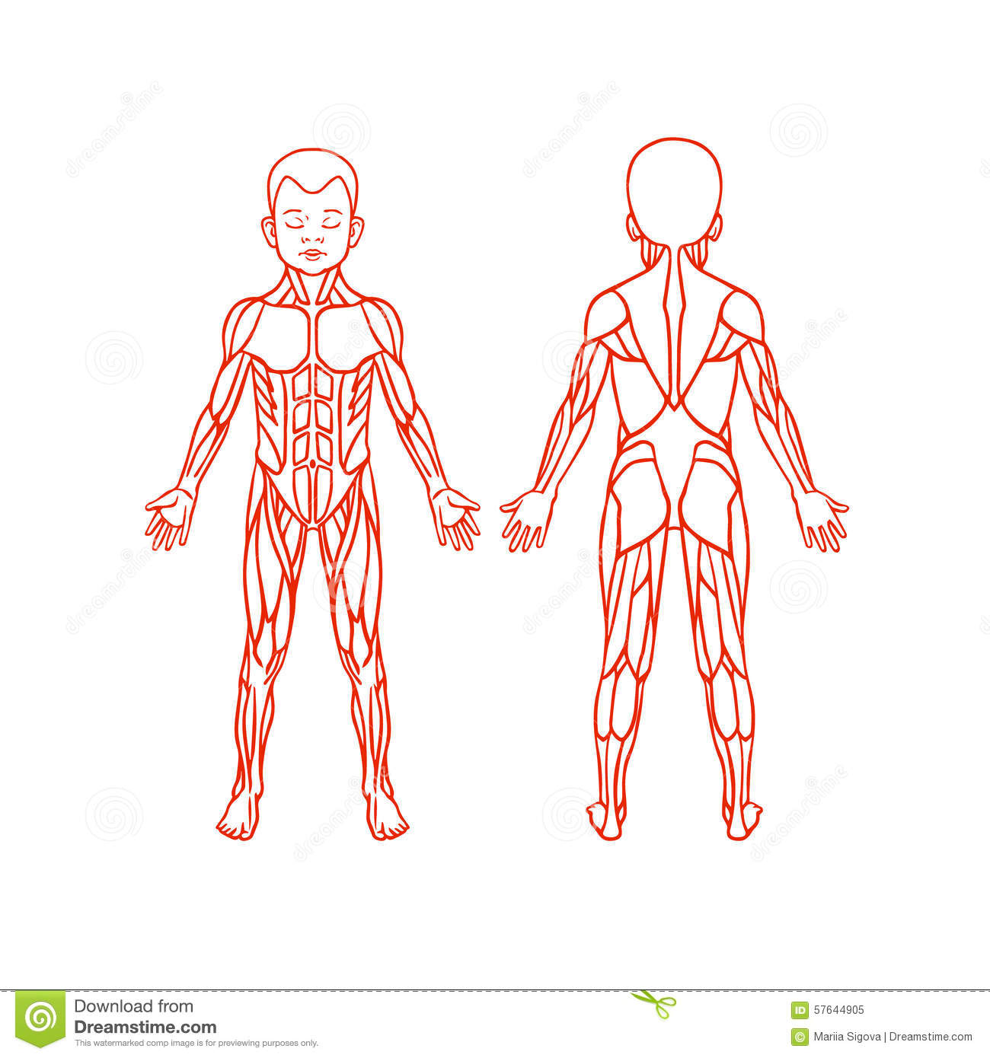

- What’s your concern level on a scale from 1 to 10?

Mild Moderate Severe
0. . . 1 . . . 2 . . . 3 . . . 4 . . . 5 . . . 6 . . . 7 . . . 8 . . . 9 . . . 10
- If there are Pain or Tantrums/behaviors, describe on a scale from 1 to 10?

Mild Moderate Severe
0. . . 1 . . . 2 . . . 3 . . . 4 . . . 5 . . . 6 . . . 7 . . . 8 . . . 9 . . . 10
4) Occurs: (Circle) Constantly Daily Weekly
Worse with: __________________________
Better with: __________________________
Approx. Date this started: _______________

Dominant Hand/Foot: Right Left

5) Please list what age (in months) that your child achieved the following skills: Hold head up alone__________
Roll over _________ Sit unsupported _________ Clap hands _________ Crawl (hands & knees) _______Walk _______

6) History/Concerns Of:
 | YES | NO |  | YES | NO
Resistance to tummy time |  |  | Locks major joints for stability
History of torticollis/head tilt |  |  | W-sitting
Difficulty with breastfeeding on one side compared to other |  |  | Moves with quick bursts of activities rather than sustained effort
3-point crawling instead of on all fours |  |  | Joints feel loose or floppy
Delayed milestones |  |  | Seems weaker or tires more easily than peers
Significant Reflux |  |  | Leans on objects/people for stability
Avoids activities where feet leave the ground |  |  | Poor flexibility
Avoids/fear of loud sounds, bright lights |  |  | Difficulty moving from one floor surface to another
Stamps/slaps feet on ground when walking |  |  | "W" Sitting
Spillage of food/drinks from their mouth |  |  | Trips/falls with changes in surfaces
Lethargic or inactive, dislikes being moved |  |  | Drags feet, poor heel-toe pattern when walking
Unable to alternate feet on stairs |  |  | Not able to sit upright going down a slide

7)Does this interfere with sleeping, family, school, or sports?
8)What are the concerns of the caregiver/teacher/coach?
9) Has your child ever had this problem/concern before?
10) Does your child have an upcoming event or plans that you would like to see improvement and be better by?
9) When will you return to see the physician who referred you for this service?
Form Completed by: __________________________________________ Date________________

